U21AD502 – APPLICATION DEVELOPMENT – ASSIGNMENT 1
NAME: JAIWANT KARRUN SA ROLLNO: 24AD048 SUBMISSION DATE: 10.09.2026
MARKS
1. User Interface  Design & Layout -  HTML Structure (15) | 2. CSS  Implementation &  JavaScript  Functionality and  Validation (15) | 3. Server-side  programming (10) | TOTAL (40)
UI Design:
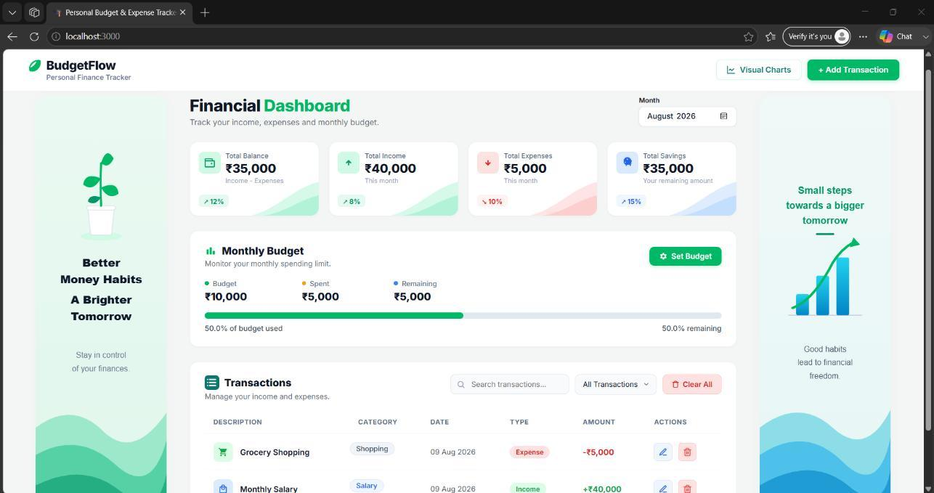
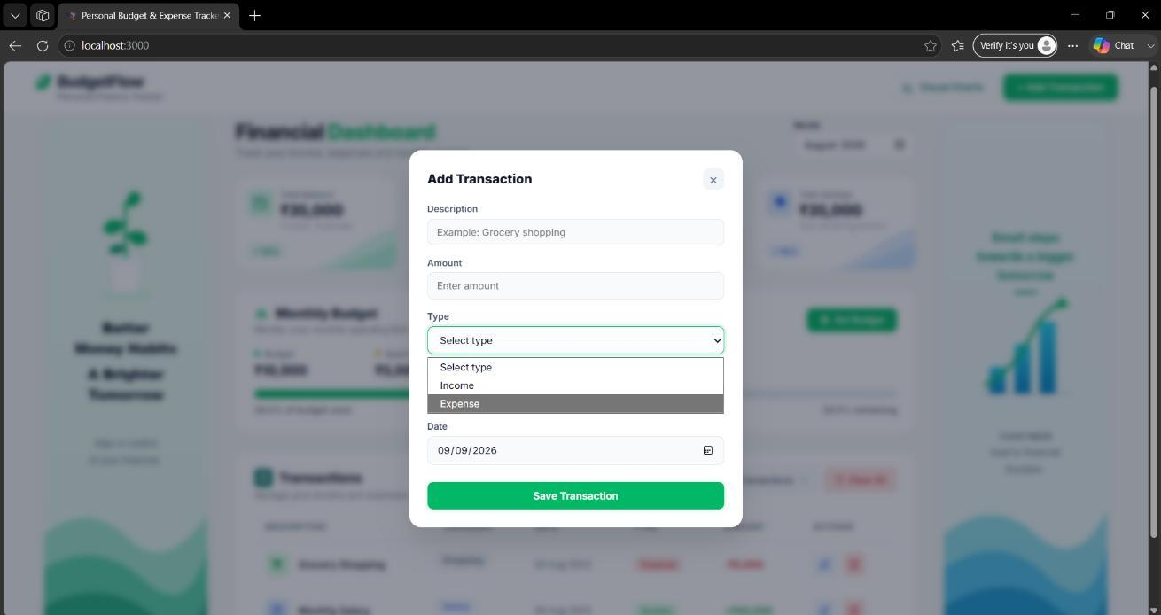

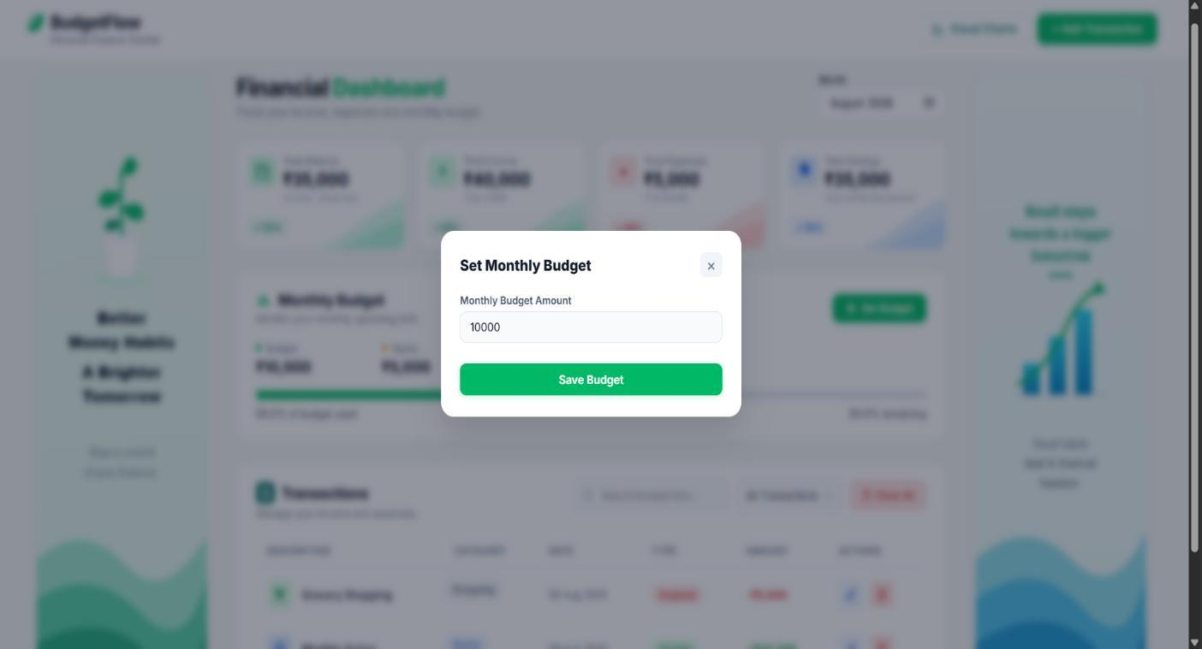
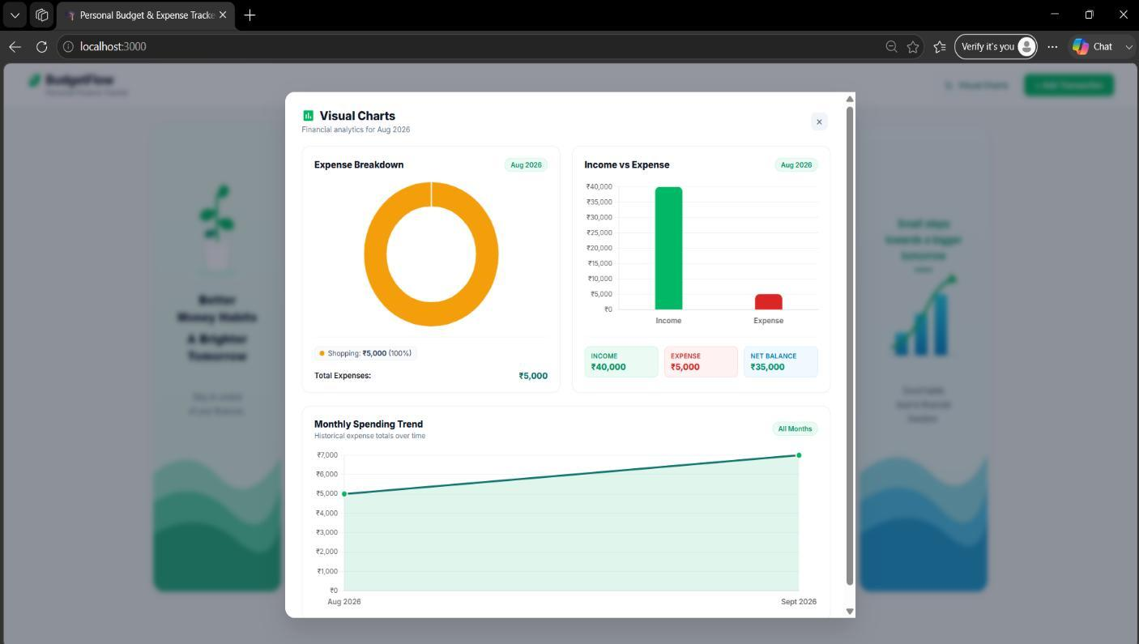

App.jsx:
import React, { useState, useEffect, useMemo } from "react";
import Navbar from "./components/Navbar";
import SummaryCards from "./components/SummaryCards";
import BudgetSection from "./components/BudgetSection";
import TransactionsSection from "./components/TransactionsSection";
import TransactionModal from "./components/TransactionModal";
import BudgetModal from "./components/BudgetModal";
import VisualChartsModal from "./components/VisualChartsModal";
import {
getTransactions,
addTransaction,
updateTransaction,
deleteTransaction,
clearAllTransactions,
getBudget,
saveBudget
} from "./services/api";

export default function App() {
const [transactions, setTransactions] = useState([]);
const [monthlyBudget, setMonthlyBudget] = useState(0);

// Default to current year-month
const [selectedMonth, setSelectedMonth] = useState(() => {
const now = new Date();
return `${now.getFullYear()}-${String(now.getMonth() + 1).padStart(2, "0")}`;
});

const [searchTerm, setSearchTerm] = useState("");
const [typeFilter, setTypeFilter] = useState("all");

// Modal state
const [isTransactionModalOpen, setIsTransactionModalOpen] = useState(false);
const [isBudgetModalOpen, setIsBudgetModalOpen] = useState(false);
const [isChartsModalOpen, setIsChartsModalOpen] = useState(false);
const [editingTransaction, setEditingTransaction] = useState(null);

// Initial load from MongoDB backend
useEffect(() => {
async function loadInitialData() {
try {
const [txRes, budgetRes] = await Promise.all([
getTransactions(),
getBudget()
]);

if (txRes && txRes.transactions) {
setTransactions(txRes.transactions);
}

if (budgetRes && typeof budgetRes.monthlyBudget === "number") {
setMonthlyBudget(budgetRes.monthlyBudget);
}
} catch (error) {
console.error("Failed to load initial data:", error);
alert(
"Unable to connect to the server.\n\nPlease make sure the Node.js/MongoDB server is running."
);
}
}

loadInitialData();
}, []);

// Global Escape key listener to close active modals
useEffect(() => {
const handleKeyDown = e => {
if (e.key === "Escape") {
setIsTransactionModalOpen(false);
setIsBudgetModalOpen(false);
setIsChartsModalOpen(false);
}
};

window.addEventListener("keydown", handleKeyDown);
return () => window.removeEventListener("keydown", handleKeyDown);
}, []);

// Monthly summary calculation (Income, Expense, Balance, Savings)
const { totalIncome, totalExpense, balance } = useMemo(() => {
const monthlyTxs = transactions.filter(t => {
return !selectedMonth || (t.date && String(t.date).startsWith(selectedMonth));
});

let income = 0;
let expense = 0;

monthlyTxs.forEach(t => {
const amt = Number(t.amount) || 0;
if (t.type === "income") income += amt;
else if (t.type === "expense") expense += amt;
});

return {
totalIncome: income,
totalExpense: expense,
balance: income - expense
};
}, [transactions, selectedMonth]);

// Filtered and sorted transactions list
const filteredTransactions = useMemo(() => {
const s = searchTerm.toLowerCase().trim();

return transactions
.filter(t => {
const desc = String(t.description || "").toLowerCase();
const cat = String(t.category || "").toLowerCase();

const matchesSearch = !s || desc.includes(s) || cat.includes(s);
const matchesType = typeFilter === "all" || t.type === typeFilter;
const matchesMonth =
!selectedMonth ||
(t.date && String(t.date).startsWith(selectedMonth));

return matchesSearch && matchesType && matchesMonth;
})
.sort((a, b) => new Date(b.date) - new Date(a.date));
}, [transactions, searchTerm, typeFilter, selectedMonth]);

// Save transaction handler (Create / Update)
const handleSaveTransaction = async transactionData => {
try {
if (editingTransaction) {
const res = await updateTransaction(
editingTransaction.id,
transactionData
);

setTransactions(prev =>
prev.map(t =>
String(t.id) === String(editingTransaction.id)
? res.transaction
: t
)
);

alert("Transaction updated successfully.");
} else {
const res = await addTransaction(transactionData);
setTransactions(prev => [res.transaction, ...prev]);

alert("Transaction added successfully.");
}

setIsTransactionModalOpen(false);
setEditingTransaction(null);
} catch (error) {
console.error("Error saving transaction:", error);
alert(error.message || "Unable to save transaction.");
}
};

// Delete single transaction
const handleDeleteTransaction = async id => {
if (!id) return;

const confirmDelete = window.confirm(
"Are you sure you want to delete this transaction?"
);
if (!confirmDelete) return;

try {
await deleteTransaction(id);
setTransactions(prev =>
prev.filter(t => String(t.id) !== String(id))
);
} catch (error) {
console.error("Error deleting transaction:", error);
alert(error.message || "Unable to delete transaction.");
}
};

// Clear all transactions
const handleClearAll = async () => {
if (!transactions || transactions.length === 0) {
alert("There are no transactions to clear.");
return;
}

const confirmClear = window.confirm(
"Are you sure you want to clear all transactions? This action cannot be undone."
);
if (!confirmClear) return;

try {
await clearAllTransactions();
setTransactions([]);
} catch (error) {
console.error("Error clearing transactions:", error);
alert(error.message || "Unable to clear transactions.");
}
};

// Save budget
const handleSaveBudget = async amount => {
try {
const res = await saveBudget(amount);
setMonthlyBudget(Number(res.monthlyBudget));
setIsBudgetModalOpen(false);
alert("Monthly budget saved successfully.");
} catch (error) {
console.error("Error saving budget:", error);
alert(error.message || "Unable to save budget.");
}
};

return (
<div>
{/* NAVBAR */}
<Navbar
onOpenCharts={() => setIsChartsModalOpen(true)}
onOpenAddTransaction={() => {
setEditingTransaction(null);
setIsTransactionModalOpen(true);
}}
/>

{/* MAIN DASHBOARD */}
<main className="container">
{/* WELCOME / HEADER */}
<section className="welcome">
<div>
<h1>Financial Dashboard</h1>
<p>Track your income, expenses and monthly budget.</p>
</div>

<div className="month-box">
<label htmlFor="monthFilter">Month</label>
<input
type="month"
id="monthFilter"
title="Select a month"
value={selectedMonth}
onChange={e => setSelectedMonth(e.target.value)}
/>
</div>
</section>

{/* SUMMARY CARDS */}
<SummaryCards
totalIncome={totalIncome}
totalExpense={totalExpense}
balance={balance}
/>

{/* BUDGET SECTION */}
<BudgetSection
monthlyBudget={monthlyBudget}
totalExpense={totalExpense}
onOpenBudgetModal={() => setIsBudgetModalOpen(true)}
/>

{/* TRANSACTIONS SECTION */}
<TransactionsSection
transactions={filteredTransactions}
searchTerm={searchTerm}
onSearchChange={setSearchTerm}
typeFilter={typeFilter}
onTypeFilterChange={setTypeFilter}
onClearAll={handleClearAll}
onEditTransaction={tx => {
setEditingTransaction(tx);
setIsTransactionModalOpen(true);
}}
onDeleteTransaction={handleDeleteTransaction}
/>
</main>

{/* MODALS */}
<TransactionModal
isOpen={isTransactionModalOpen}
onClose={() => {
setIsTransactionModalOpen(false);
setEditingTransaction(null);
}}
onSave={handleSaveTransaction}
editingTransaction={editingTransaction}
/>

<BudgetModal
isOpen={isBudgetModalOpen}
onClose={() => setIsBudgetModalOpen(false)}
currentBudget={monthlyBudget}
onSaveBudget={handleSaveBudget}
/>

<VisualChartsModal
isOpen={isChartsModalOpen}
onClose={() => setIsChartsModalOpen(false)}
transactions={transactions}
selectedMonth={selectedMonth}
/>
</div>
);
}

main.jsx:
import { StrictMode } from 'react'
import { createRoot } from 'react-dom/client'
import './index.css'
import App from './App.jsx'

createRoot(document.getElementById('root')).render(
<StrictMode>
<App />
</StrictMode>,
)

server.js:
const path = require("path");
require("dotenv").config({ path: path.join(__dirname, ".env") });
require("dotenv").config(); // Fallback to root .env if present

const express = require("express");
const cors = require("cors");
const mongoose = require("mongoose");
const fs = require("fs");

const Transaction = require("./models/Transaction");
const Budget = require("./models/Budget");

const app = express();
const PORT = process.env.PORT || 5000;
const MONGODB_URI =
process.env.MONGODB_URI || "mongodb://127.0.0.1:27017/budgetflow";

// ==========================================
// MIDDLEWARE
// ==========================================

app.use(cors());
app.use(express.json());

// Serve static React build if it exists
const clientDistPath = path.join(__dirname, "..", "client", "dist");

if (fs.existsSync(clientDistPath)) {
app.use(express.static(clientDistPath));
}

// ==========================================
// MONGODB CONNECTION & AUTO-MIGRATION
// ==========================================

async function connectDB() {
try {
await mongoose.connect(MONGODB_URI);
console.log("Connected to MongoDB successfully at:", MONGODB_URI);

// Auto-migration from existing budget-data.json if MongoDB is empty
await autoMigrateFromJson();
} catch (error) {
console.error("MongoDB connection error:", error.message);
console.log("Please ensure MongoDB is running on your machine.");
}
}

async function autoMigrateFromJson() {
try {
const count = await Transaction.countDocuments();
if (count === 0) {
let dataFile = path.join(__dirname, "data", "budget-data.json");
if (!fs.existsSync(dataFile)) {
dataFile = path.join(__dirname, "..", "data", "budget-data.json");
}

if (fs.existsSync(dataFile)) {
const raw = fs.readFileSync(dataFile, "utf8");
const jsonData = JSON.parse(raw);

if (Array.isArray(jsonData.transactions) && jsonData.transactions.length > 0) {
await Transaction.insertMany(jsonData.transactions);
console.log(
`[Migration] Successfully imported ${jsonData.transactions.length} transactions into MongoDB.`
);
}

if (typeof jsonData.monthlyBudget === "number" && jsonData.monthlyBudget > 0) {
await Budget.findOneAndUpdate(
{ key: "current_budget" },
{ monthlyBudget: jsonData.monthlyBudget },
{ upsert: true, returnDocument: "after" }
);
console.log(
`[Migration] Imported monthly budget (₹${jsonData.monthlyBudget}) into MongoDB.`
);
}
}
}
} catch (err) {
console.warn("[Migration Notice] Could not auto-migrate from JSON:", err.message);
}
}

connectDB();

// ==========================================
// TRANSACTION VALIDATION HELPER
// ==========================================

function validateTransaction(data) {
if (typeof data.description !== "string" || data.description.trim() === "") {
return "Description is required.";
}

if (
typeof data.amount !== "number" ||
!Number.isFinite(data.amount) ||
data.amount <= 0
) {
return "Amount must be greater than zero.";
}

if (data.type !== "income" && data.type !== "expense") {
return "Transaction type must be income or expense.";
}

if (typeof data.category !== "string" || data.category.trim() === "") {
return "Category is required.";
}

if (
typeof data.date !== "string" ||
!/^\d{4}-\d{2}-\d{2}$/.test(data.date)
) {
return "Valid date is required.";
}

return null;
}

// ==========================================
// GET TRANSACTIONS
// ==========================================

app.get("/api/transactions", async function (req, res) {
try {
const transactions = await Transaction.find().sort({ date: -1, createdAt: -1 });

res.status(200).json({
success: true,
transactions: transactions.map(t => ({
id: t.id,
description: t.description,
amount: t.amount,
type: t.type,
category: t.category,
date: t.date
}))
});
} catch (error) {
console.error("Error retrieving transactions:", error);
res.status(500).json({
success: false,
message: "Unable to retrieve transactions from database."
});
}
});

// ==========================================
// ADD TRANSACTION
// ==========================================

app.post("/api/transactions", async function (req, res) {
try {
const amount = Number(req.body.amount);

const transactionData = {
description: req.body.description,
amount,
type: req.body.type,
category: req.body.category,
date: req.body.date
};

const validationError = validateTransaction(transactionData);
if (validationError) {
return res.status(400).json({
success: false,
message: validationError
});
}

const newId = Date.now();
const createdTransaction = await Transaction.create({
id: newId,
description: transactionData.description.trim(),
amount: transactionData.amount,
type: transactionData.type,
category: transactionData.category.trim(),
date: transactionData.date
});

res.status(201).json({
success: true,
message: "Transaction added successfully.",
transaction: {
id: createdTransaction.id,
description: createdTransaction.description,
amount: createdTransaction.amount,
type: createdTransaction.type,
category: createdTransaction.category,
date: createdTransaction.date
}
});
} catch (error) {
console.error("Error adding transaction:", error);
res.status(500).json({
success: false,
message: "Server error while adding transaction."
});
}
});

// ==========================================
// UPDATE TRANSACTION
// ==========================================

app.put("/api/transactions/:id", async function (req, res) {
try {
const targetId = Number(req.params.id);
const amount = Number(req.body.amount);

const transactionData = {
description: req.body.description,
amount,
type: req.body.type,
category: req.body.category,
date: req.body.date
};

const validationError = validateTransaction(transactionData);
if (validationError) {
return res.status(400).json({
success: false,
message: validationError
});
}

const updatedTransaction = await Transaction.findOneAndUpdate(
{ id: targetId },
{
description: transactionData.description.trim(),
amount: transactionData.amount,
type: transactionData.type,
category: transactionData.category.trim(),
date: transactionData.date
},
{ returnDocument: "after" }
);

if (!updatedTransaction) {
return res.status(404).json({
success: false,
message: "Transaction not found."
});
}

res.status(200).json({
success: true,
message: "Transaction updated successfully.",
transaction: {
id: updatedTransaction.id,
description: updatedTransaction.description,
amount: updatedTransaction.amount,
type: updatedTransaction.type,
category: updatedTransaction.category,
date: updatedTransaction.date
}
});
} catch (error) {
console.error("Error updating transaction:", error);
res.status(500).json({
success: false,
message: "Server error while updating transaction."
});
}
});

// ==========================================
// DELETE ALL TRANSACTIONS (CLEAR ALL)
// ==========================================

app.delete("/api/transactions", async function (req, res) {
try {
await Transaction.deleteMany({});

res.status(200).json({
success: true,
message: "All transactions cleared successfully."
});
} catch (error) {
console.error("Error clearing transactions:", error);
res.status(500).json({
success: false,
message: "Server error while clearing transactions."
});
}
});

// ==========================================
// DELETE SINGLE TRANSACTION
// ==========================================

app.delete("/api/transactions/:id", async function (req, res) {
try {
const targetId = Number(req.params.id);

const deleted = await Transaction.findOneAndDelete({ id: targetId });

if (!deleted) {
return res.status(404).json({
success: false,
message: "Transaction not found."
});
}

res.status(200).json({
success: true,
message: "Transaction deleted successfully."
});
} catch (error) {
console.error("Error deleting transaction:", error);
res.status(500).json({
success: false,
message: "Server error while deleting transaction."
});
}
});

// ==========================================
// GET BUDGET
// ==========================================

app.get("/api/budget", async function (req, res) {
try {
const budgetDoc = await Budget.findOne({ key: "current_budget" });

res.status(200).json({
success: true,
monthlyBudget: budgetDoc ? budgetDoc.monthlyBudget : 0
});
} catch (error) {
console.error("Error retrieving budget:", error);
res.status(500).json({
success: false,
message: "Unable to retrieve budget."
});
}
});

// ==========================================
// SAVE BUDGET
// ==========================================

app.post("/api/budget", async function (req, res) {
try {
const amount = Number(req.body.amount);

if (!Number.isFinite(amount) || amount <= 0) {
return res.status(400).json({
success: false,
message: "Budget amount must be greater than zero."
});
}

const budgetDoc = await Budget.findOneAndUpdate(
{ key: "current_budget" },
{ monthlyBudget: amount },
{ upsert: true, returnDocument: "after" }
);

res.status(200).json({
success: true,
message: "Budget saved successfully.",
monthlyBudget: budgetDoc.monthlyBudget
});
} catch (error) {
console.error("Error saving budget:", error);
res.status(500).json({
success: false,
message: "Server error while saving budget."
});
}
});

// ==========================================
// UNKNOWN API ROUTE
// ==========================================

app.use("/api", function (req, res) {
res.status(404).json({
success: false,
message: "API endpoint not found."
});
});

// ==========================================
// CLIENT FALLBACK ROUTE
// ==========================================

app.use(function (req, res) {
if (fs.existsSync(path.join(clientDistPath, "index.html"))) {
res.sendFile(path.join(clientDistPath, "index.html"));
} else {
res.status(404).send("Application build not found.");
}
});

// ==========================================
// GLOBAL ERROR HANDLER
// ==========================================

app.use(function (error, req, res, next) {
console.error("Unexpected error:", error);
res.status(500).json({
success: false,
message: "Internal server error."
});
});

// ==========================================
// START SERVER
// ==========================================

app.listen(PORT, function () {
console.log("");
console.log("======================================");
console.log(" BudgetFlow Backend Server Started");
console.log("======================================");
console.log(`Server: http://localhost:${PORT}`);
console.log(`Transactions: http://localhost:${PORT}/api/transactions`);
console.log(`Budget: http://localhost:${PORT}/api/budget`);
console.log(`Database: ${MONGODB_URI}`);
console.log("======================================");
});

Transaction.js:
const mongoose = require("mongoose");

const TransactionSchema = new mongoose.Schema(
{
id: {
type: Number,
required: true,
unique: true,
default: () => Date.now()
},
description: {
type: String,
required: [true, "Description is required."],
trim: true
},
amount: {
type: Number,
required: [true, "Amount is required."],
min: [0.01, "Amount must be greater than zero."]
},
type: {
type: String,
required: [true, "Transaction type is required."],
enum: {
values: ["income", "expense"],
message: "Transaction type must be income or expense."
}
},
category: {
type: String,
required: [true, "Category is required."],
trim: true
},
date: {
type: String,
required: [true, "Valid date is required."],
match: [/^\d{4}-\d{2}-\d{2}$/, "Date must be in YYYY-MM-DD format."]
}
},
{
timestamps: true,
toJSON: {
transform: function (doc, ret) {
delete ret.__v;
return ret;
}
}
}
);

TransactionSchema.index({ date: -1 });

module.exports = mongoose.model("Transaction", TransactionSchema);

